**Memory Allocation Strategies**

Memory allocation is a process by which computer programs are assigned memory or space.

Here, main memory is divided into two types of partitions

1. **Low Memory** – Operating system resides in this type of memory.
2. **High Memory**– User processes are held in high memory.

## Partition Allocation

Memory is divided into different blocks or partitions. Each process is allocated according to the requirement. Partition allocation is an ideal method to avoid internal fragmentation.

Below are the various partition allocation schemes:

* **First Fit**: In this type fit, the partition is allocated, which is the first sufficient block from the beginning of the main memory.
* **Best Fit:**It allocates the process to the partition that is the first smallest partition among the free partitions.
* **Worst Fit:**It allocates the process to thepartition, which is the largest sufficient freely available partition in the main memory.
* **Next Fit:** It is mostly similar to the first Fit, but this Fit, searches for the first sufficient partition from the last allocation point.

## What is Paging?

Paging is a storage mechanism that allows OS to retrieve processes from the secondary storage into the main memory in the form of pages. In the Paging method, the main memory is divided into small fixed-size blocks of physical memory, which is called frames. The size of a frame should be kept the same as that of a page to have maximum utilization of the main memory and to avoid external fragmentation. Paging is used for faster access to data, and it is a logical concept.

## What is Fragmentation?

Processes are stored and removed from memory, which creates free memory space, which are too small to use by other processes.

After sometimes, that processes not able to allocate to memory blocks because its small size and memory blocks always remain unused is called fragmentation. This type of problem happens during a dynamic memory allocation system when free blocks are quite small, so it is not able to fulfill any request.

Two types of Fragmentation methods are:

1. Internal fragmentation
2. External fragmentation

* External fragmentation can be reduced by rearranging memory contents to place all free memory together in a single block.
* The internal fragmentation can be reduced by assigning the smallest partition, which is still good enough to carry the entire process.

**1. Internal Fragmentation:**   
Internal fragmentation happens when the memory is split into mounted-sized blocks. Whenever a method is requested for the memory, the mounted-sized block is allotted to the method. In the case where the memory allotted to the method is somewhat larger than the memory requested, then the difference between allotted and requested memory is called internal fragmentation. We fixed the sizes of the memory blocks, which has caused this issue. If we use dynamic partitioning to allot space to the process, this issue can be solved.

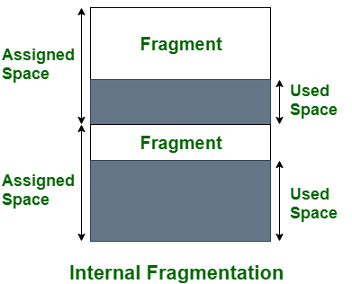

***Internal Fragmentation***

The above diagram clearly shows the internal fragmentation because the difference between memory allocated and required space or memory is called [Internal fragmentation](https://www.geeksforgeeks.org/what-is-fragmentation-in-operating-system/).

**2. External Fragmentation:**   
External fragmentation happens when there’s a sufficient quantity of area within the memory to satisfy the memory request of a method. However, the process’s memory request cannot be fulfilled because the memory offered is in a non-contiguous manner. Whether you apply a first-fit or best-fit memory allocation strategy it’ll cause [external fragmentation](https://www.geeksforgeeks.org/what-is-fragmentation-in-operating-system/).

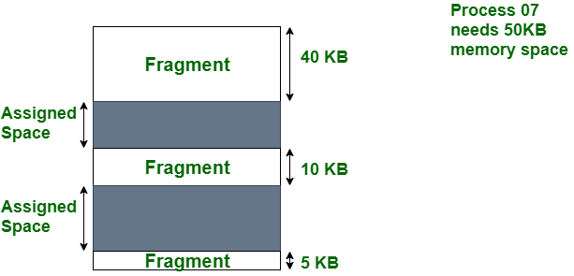

* ***External Fragmentation***

In the above diagram, we can see that, there is enough space (55 KB) to run a process-07 (required 50 KB) but the memory (fragment) is not contiguous. Here, we use compaction, paging, or segmentation to use the free space to run a process.